POPULATION SIZE AND LONG-TERM SELECTION

Kenneth Weber
Biology Department
University of Southern Maine
96 Falmouth St.
Portland, ME 04103

Telephone: (207)-780-4265
Fax: (207)-228-8116
Email: keweber@usm.maine.edu

I. A BRIEF REVIEW OF EXPERIMENTAL RESULTS

A. Response Rates and Population Size
Selection is more efficient in large, panmictic populations than in small ones, as a mechanism for the sorting and concentration of small effects that contribute to the narrow-sense, additive component of heritability. This advantage can be detected even in short-term selection, and becomes substantial in the longer term. Mutation also contributes more to response in larger populations. In most experimental time frames, its total contribution is small compared to the contribution from standing genetic variation, but it becomes important in the very long term (Keightley, this volume).
Quite a few experiments have demonstrated increased response in larger populations, on timescales too short for mutation to play a significant role. The first such experiment was presented in three papers by Frankham, et al. (1968a), Jones, et al. (1968), and Frankham, et al. (1968b). Abdominal bristle number in Drosophila melanogaster was selected in replicated combinations of four selection intensities and three population sizes-- 10, 20, and 40 pairs of parents. By the twelfth generation, there was a clear trend toward superior response in the larger lines (Frankham, et al., 1968a, Figure 1). (At this point the lowest-intensity lines were terminated.) By the end of the experiment at generation 50, the differences in response were strikingly in favor of larger populations (Jones, et al. 1968, Figure 1). In every comparison of treatment means at the same selection intensity, larger populations evolved more than smaller ones. These differences were becoming steadily larger as the experiment progressed, and none of the lines had plateaued at the end. There was no indication that the largest population sizes were nearing a limit where the magnitude of the population size effect would begin to decline. In fact, at each selection intensity, the difference between the 40-pair lines and the 20-pair lines was about the same as the difference between the 20-pair lines and the 10-pair lines. Therefore it seemed likely that even larger populations would have yielded still higher gains within the same amount of time.
In generation 16, new lines of the smallest size (10 pairs of parents) were sublined from the lines of the largest size (40 pairs), at the same selection intensities. This addressed the question of whether population size can safely be reduced after selection has had some time to raise the frequency of initially-rare favorable alleles (Robertson 1960; James 1971). In this case, response in all the small sublines immediately lagged behind response in the large, original lines, and the differences in response continued to increase to the end of the experiment.
The second experiment of this type was reported by Hanrahan, et al. (1973), Eisen, et al. (1973) and Eisen (1975), who selected on postweaning weight gain in mice using two selection intensities and five population sizes-- 1, 2, 4, 8 and 16 pairs of parents-- replicated in all combinations. This study carefully maintained effective population sizes by selecting only within litters, equalizing the contribution of each family in both sexes. The two smallest population sizes were terminated at generation 14, and the other three at generations 21-27. Within each level of selection intensity, average realized heritability and cumulative selection response increased as a function of population size.
These two initial explorations of the subject are still in many ways the best. Each included a spectrum of sizes and intensities, and continued long enough to reach firm conclusions about long term effects. These studies demonstrated that population size has a continuing, cumulative effect on the rate of response to selection: selection for longer times continues to increase the magnitudes of differences in total response. The effect of population size is strong even at sizes above those typical of most selection experiments. However, neither study attempted to convey one of the most provocative aspects of its results, and so I have taken the liberty of distilling the endpoint data from both studies graphically, in a way that may do so (Figure 1, A and B). In these graphs, the trend of the data strongly suggests that even larger sizes would have yielded still larger increases in response, at all selection intensities, within the same number of generations.

FIGURE ONE
In a related experiment, Ruano et al. (1975) selected on egg-laying rate in Tribolium castaneum, always scoring the same number of females (200) per line, but selecting the top 5%, 10%, 20%, 33%, 50%, and 100% (with two replicates per line) so that intensities were inversely correlated with population sizes. Higher-intensity lines responded more rapidly for the first 10 generations, but then more slowly. Lines of lower selection intensity (and therefore larger population size) continued to respond at slower rates, but with less decline in rate, so that eventually they began to catch up. When the experiment was terminated at generation 32, all lines were still responding, but total response was converging, and only the lines at lowest intensity and largest size were still responding linearly, at an undiminished rate. The design of this experiment doesn't permit the effect of size to be isolated from the effect of intensity, but the overall picture is one of early response dictated by selection intensity, slowly moving toward response dictated by population size.
In the first two studies, where direct comparisons could be made among populations differing only in size, the advantage of larger populations was already apparent in the short term. The trend in favor of size was documented in early reports at generation 12 in Frankham, et al. (1968) and at generation 14 in Hanrahan et al. (1973). There have been a number of other experimental studies on the short term effect of population size on heritability— defined here as shorter than 20 generations (vd. Eisen 1980). On the whole they reinforce the conclusion that large populations utilize standing variation more efficiently, and more rapidly.
Barker and Karlsson (1974) studied the effects of intense disruptive selection as a possible prelude to speciation, using sternopleural bristle number in D. melanogaster. This was again an investigation of both selection intensity and population size, in four treatment combinations using selection pressures of 0.025% (1 in 40) and 50%, with population sizes of 8 pairs and 40 pairs of selected parents. Selection continued for 17 generations. In the combination at high intensity and large size (which was unreplicated) they found a significant response in terms of the divergence between the extreme members of the population, and also a significant tendency to assortative mating. The other combinations were ineffective.
Silvela, et al. (1989) selected for percent oil in maize kernels, at selection pressures of 5% and 17%, with population sizes of 6, 10, and 50 individuals. Small, medium and large populations had 5, 4 and 2 replicates, respectively, at both selection pressures. Although the experiment only lasted for 10 generations, the results show the advantage of larger size in all comparisons. The 10th generation means are not quite in order of size, but the means of the last 4 (or last 3, or last 2) generations are completely in order of population size across treatments (Silvela, et al. 1989, Table 3). Realized heritabilities and regressions of response on generation number were also completely in order of population size. In this experiment the effects of population size were not yet large but were clearly emerging after 10 generations.
By contrast, Blow and Briggs (1973) selected for 10 generations for body weight in quail, at a selection intensity of 25% with population sizes of 10, 20, and 30 pairs of parents, and found no effect of population size. There were two replicates per treatment. Considering all studies of this type, it appears that experiments of this short duration will not always detect a clear effect of population size unless there are many replicates and large differences in population size. Nevertheless, several well-replicated selection experiments have detected an advantage in larger populations after surprisingly few generations. Vasquez and Bohren (1982) reported a small, significant effect of population size in an experiment lasting only three generations, selecting for body weight in chickens at three effective sizes (N_{e}'s of approximately 4, 7, and 15), at a single selection intensity, with four replicates per treatment. Campo and Turrado (1997) selected on Tribolium for an index of adult and pupal weight, at five population sizes (1, 2, 4, 8 and 16 pairs of parents) and four selection intensities, with three replicates per combination, for only four generations. They, too, found a significant effect of population size overall.
One has to wonder what endpoints exist, as population size and generation number increase. This was the challenge that led to the development of several devices for automated mass selection on D. melanogaster. One of these (Weber 1988a) measured the wing-tip height of standing, cold-torpid flies that were homozygous for the allele raised (rsd), which causes vertical wings. This system permitted rapid selection on large numbers of flies for a trait that was partly morphological, partly behavioral, and perhaps partly physiological. About 20% of the response was due to increases in body size. Populations of three approximate sizes were tested-- 40, 200, and 1000 selected parents-- at 20% selection. Selection was continued for 55 generations. Cumulative response was in order of population size for all replicates at all three sizes (Weber 1990, Figures 2 and 3). Treatment means of cumulative response were a nearly linear function of the log of effective population size (Figure 2A).
The second mass-selection system (Weber 1988b) measured resistance to ethanol vapor in flies, in terms of the minutes of exposure to a controlled dose required to make flies fall through a series of baffles into the advancing tubes of a fraction collector. The population sizes were 160 and 1600 selected parents, selection pressure was approximately 20%, and selection continued for 65 generations (Weber and Diggins 1990). Again, cumulative response was significantly higher in the larger lines (Figure 2B).

FIGURE 2
In Weber (1990) and in Weber and Diggins (1990), populations that were already large by previous standards were compared with populations that were five to ten times larger. Both experiments demonstrated that selection was still more effective in these extremely large populations. However, when such large sizes are compared, it takes more time for the advantage of larger size to emerge. The larger the populations, the longer the time required. Yet the differences still emerged well before the end of the experiments. In fact, the effects of size were clear by generation 30 for wing-tip height (Weber 1990) and by generation 20 for ethanol resistance (Weber and Diggins 1990). Moreover, the total times involved-- 55 and 65 generations, respectively-- were not extremely long. They were much too short for the treatment differences to be attributed solely to the greater accumulation of new mutations in large populations. The lesson seems to be that large populations are better at concentrating small effects that are available in standing genetic variance. Although these experiments enter new size ranges, they leave the same question as before: at what population sizes do larger numbers cease to make a difference in terms of extracting genetic variation? Populations of increasing size become deterministic for smaller allelic differences, but these differences must become exhausted in a finite gene pool. It appears that experiments large enough to find this limit would run into timescales where mutation becomes important, and would require parallel selection on inbred lines to quantify that component.
Considering these facts, it seemed that the best way forward in the investigation of large populations was to abandon further experimental comparisons of population size—because they become quite laborious even with automated systems— and to concentrate all efforts instead on selection at the largest size possible, for the longest possible time. It has now been 14 years since the beginning of the wind tunnel selection experiment (Weber 1988c). In this experiment two populations, of approximately 2000 parents each, are selected from the top 2%-6% of flies in a 1.5 m long compartmented wind tunnel, in which they fly upwind towards a light. Wind velocity is constant in each chamber but falls evenly along the tunnel via uniform outlets in each chamber. Flies arrive at a final distribution in the wind tunnel reflecting their individual abilities to contend with wind and turbulence. The whole sample is then anesthetized by a sudden transition from air to CO₂.
The phenotype of wind tunnel performance, expressed as the mean apparent flying speed (or mean cross-sectional wind tunnel air speed), responded rapidly to the intense selection. Over the first 100 generations (Weber 1996), the phenotype increased from about 2 cm/sec to 170 cm/sec. By this time, response had slowed, without reaching a plateau. The great differentiation between the phenotypic distributions of the selected lines and the controls (Weber 1996, Figure 2) already suggested a highly polygenic basis for the trait. This was supported by the saltational, nearly vertical response to selection on hybrid lines (Weber 1996, Figure 5), indicating that selection had created linkages between many contributory alleles.
Although the wind tunnel experiment does not include a comparison of different population sizes, the effect of population size in this experiment and in others can be compared by converting all responses to a common scale. Figure 3 shows results from eleven different selection experiments on ten traits in four organisms, at 17 population sizes. The common scale of response is the ratio of response in generation 50 to response after one generation (R₅₀/R₁). Factors such as selection intensity and heritability cancel out. The figure shows the longer continuation of response in larger populations. The two sigmoid lines show R₅₀/R₁, calculated from the model of Robertson (1960) and Hill (1982), in the form presented in Weber and Diggins (1990) for the prediction of response at finite generation times. The upper line shows response including the cumulative effect of new mutations. The lower line omits mutation. Under these assumptions, most of the increased response in larger populations at generation 50 comes from better utilization of initial genetic variation.

FIGURE 3
Traits like bristle number in flies (Jones, et al. 1968) and body weight in mice (Eisen, et al. 1973) are measured on one individual at a time. By contrast, the traits of wing-tip height, ethanol resistance and wind tunnel performance are mass measurements, subject to increased measurement error. Automation improves, and accuracy declines. This lowers realized heritability and may also increase the advantage of larger sizes. In any case, as Figures 1 and 2 show, bigger populations are better, and the advantage appears to extrapolate to population sizes that are still out of experimental range, whether for individually-measured traits (Figure 1) or for mass-measured traits (Figure 2). Figure 3 suggests that all traits may be much alike in their fundamental dependence on population size.

B. Fitness Interactions and Population Size
To this point, this review has focused solely on heritability and selection response in selected traits. The second great concern in any selection experiment is the trait of fitness. Fitness is sometimes ignored in theoretical and experimental studies of selection response, but changes in fitness are typically a correlated effect of extreme phenotypic change in experimental selection (Falconer and Mackay 1996). It is almost as likely that fitness will decline during selection, as it is that the selected trait will increase. Even in conventionally large selection experiments (Enfield 1977, 1980; Yoo 1980), where inbreeding was not as obvious a problem, various severe fitness problems have appeared. Sooner or later in any selection line, there are usually reductions in vitality and reproductive capacity, often associated with unpredictable and peculiar genetic syndromes. Moreover, under selection an opposition usually develops between fitness and the selected trait. This can come from various causes and produces a rapid, immediate decline in the phenotype when selection is relaxed.
Fitness interactions have been considered in several studies of population size in selection. Frankham et al. (1968b) thoroughly investigated the tendency for relaxed lines to regress, at five-generation intervals throughout their experiment on abdominal bristles. In the later generations, several lines showed large declines in the selected trait when relaxed, and these were mainly lines with major recessive lethals affecting the trait. The most extreme case of this was the unreplicated line representing the combination of largest size and highest intensity. Eisen et al. (1973) noted that their two smallest population sizes suffered loss of fertility, while their largest populations suffered general losses of reproductive fitness as measured by size, weight and survival of litters. Reasoning partly from comparisons with control lines, they attributed the fitness loss in the small lines to inbreeding, and the fitness loss in the largest lines to genetic interactions between fitness and the selected trait. The essence of both Frankham et al. (1968b) and Eisen et al. (1973) was that the largest lines showed the most total response to selection, but also the greatest fitness problems.
In the automated selection experiments on wing-tip height (Weber 1990) and ethanol vapor resistance (Weber and Diggins 1990), no measurements of any kind were made of fitness traits or interactions. This is regrettable because serious fitness problems did become evident. In the first experiment, the smallest lines became difficult to maintain and perished soon after the experiment terminated. In the second experiment, one of the smaller lines far exceeded the other lines of its size in its response, but this same line also developed extreme viability problems. None of the largest lines in either of these experiments showed obvious fitness problems, despite their higher response. Thus these observations do not support the idea that the larger responses of larger populations lead to correspondingly large fitness problems.
In the very large wind tunnel selection lines (Weber 1996), two critical tests failed to find evidence of fitness interactions. The first test was a direct assay of competitive fitness, in which either control or selected females were allowed to compete against white-eyed females from the same tester stock. This is a standard test of fitness that encompasses fecundity, egg-to-adult viability, and larval competitive ability. At generation 50 this test failed to show a significantly higher percentage of red-eyed flies emerging in control lines compared to selected lines. In generation 85, the same test again failed to find a significant difference.
The second test looked for a decline in the phenotype of the selected lines after relaxation of selection. Lines relaxed in generation 65 for 30 generations, and in generation 85 for 10 generations, did not regress detectably. Lack of regression, upon relaxation after extreme selection, is not unknown. For example, in Yoo (1980), out of six replicate populations selected for 86-89 generations for abdominal bristle number, five replicates regressed rapidly after relaxation, but one remained stable, declining only slightly during 35 generations of observation. There are also undoubtedly differences in how easily large changes can be tolerated in particular traits. For example, in the Illinois long-term selection experiment, as the percent oil nears zero in the line selected for low oil, extreme fitness problems have developed (Dudley and Lambert 1992). Thus, there may be no substitute for a certain minimum oil content in the maize kernel. In the wind tunnel lines, the underlying traits that are being increased by selection are probably all fairly compatible with fitness, and unlikely to develop a direct phenotypic antagonism to it. Nevertheless, fitness problems have arisen during selection on many other seemingly peripheral traits. In the wind tunnel selection lines, the absence of either regression or competitive fitness loss, despite the extreme selection pressure and the long period of response, is rather unusual. It suggests some unusual explanatory factor, and the most unusual aspect of these populations is their large size.

II. NEW RESULTS
To be complete, this review must mention some more-recent results in the ongoing wind tunnel experiment, as a preview of coming publications. Since generation 100, there has been substantial additional response to selection. Now, as Figure 4 shows, the experiment has finally arrived at a plateau stage where response is very slow. Numerous aspects of the phenotype appear to show adaptation for wind tunnel performance. One of the most important components is positive phototaxis. Phototaxis is strongly developed in these flies (Figure 5), to an extent that is noticeable even during routine handling. Another aspect of the selected phenotype is larger body size (Table 1). These changes add to the evidence for the involvement of many genes in wind tunnel performance.

FIGURE 4

FIGURE 5

TABLE 1
The earlier results, suggesting a lack of fitness interactions, have also been completely confirmed. New relaxed lines were started in generation 232 and were followed for the next 68 generations. They appear to have regressed very little, if at all (Figure 6). Moreover, in a combined assay of egg-to-adult survival and larval competitive ability (Table 2), at generation 330, the selected lines still show no deficiency compared to controls.

FIGURE 6

TABLE 2
These results can be compared with several previous selection experiments on phototaxis and body size in fruit flies, where measurements of fitness interactions were also carried out. In these experiments, strong fitness interactions were reported for both these traits. Thus the present results would not have been predicted from past results. For example, Dobzhansky and Spassky (1969) selected for positive and negative phototaxis in D. pseudoobscura for 20 generations. When selection was relaxed for 20 subsequent generations, the up and down lines both regressed to the point where they became almost indistinguishable. Again, Tantawy, et al. (1964) selected for longer and shorter wings in D. melanogaster for 20 generations. (Wing length is frequently used as a parameter of body size.) They simultaneously measured egg-to-adult viability and found that it decreased in all four selection lines, to approximately 65%-80% of controls (Tantawy, et al. 1964, Figure 3). Similarly, Prevosti (1956) selected for longer and shorter wings, on D. subobscura, and also measured egg-to-adult viability during the experiment. It was reduced to 40%-80% of controls (Prevosti, 1956, Figures 3 and 4).
Actually, the cited reports on phototaxis and body size are not different from the majority of results for other experimentally selected traits. Most selection experiments show negative fitness interactions, when these are measured. With prolonged selection, these interactions often become sufficiently deleterious to force the eventual termination of selection.

III. POPULATION SIZE AND EFFICIENCY IN SELECTION
Most of the results reviewed here can be summarized in the statement that larger population size, in an outbred stock, accelerates and prolongs response in the selected trait, leading to a higher plateau. The plateau stage, representing the essential exhaustion of the initial, selectable additive genetic variation for the trait, is of course not the ultimate end of response, because mutation continues. Indeed, in the Illinois long-term selection experiment on Zea mays, mutation rates may be high enough to have obscured the loss of initial genetic variation (Walsh, this volume). However, the plateau is usually a recognizable, terminal, perpetual phase of slow response.
In the first one or two generations of selection, the effect of population size is too small to detect. Initial heritability is not noticeably affected by the numbers scored, nor by the size of the founding population (short of intentional inbreeding) even if it is very small (Roff and Mousseau 1987). Realized heritability over the somewhat longer short term shows the effect of population size in well replicated tests. Nevertheless, realized heritability in early generations still does not predict the eventual response at the plateau stage when standing variability is exhausted. The magnitude of the plateau depends on, and indeed is a kind of assay of, the trait's genetic architecture, especially its polygenicity.
At any population size, it is at least theoretically true that over the long term, the most polygenic traits will continue to respond the longest and will evolve the farthest in terms of the base-population phenotypic standard deviation. This is the basis for the Castle-Wright formula (Castle 1921; Falconer and Mackay 1996), for effective gene number or apparent polygenicity. Other genetic factors can prolong the period of response, in the sense of slowing it down-- factors such as linkage and low initial frequencies of favorable alleles. These and other factors also decrease the accuracy of the Castle-Wright formula (Lande 1981; Zeng, et al. 1990), without detracting from its logical basis.
Every selection regime involves the operation of selection, tending to fix favorable alleles, and the process of drift, tending to fix alleles at random. Drift is reduced in larger populations, hence allelic diversity persists and allows selection more time, permitting greater utilization of genetic variation. But the expected response in larger populations is not only greater at the limit, it is more rapid at all times. Favorable alleles rise in frequency faster in larger populations. They would do so, even if every gene moved by its own centromere, but the existence of linkage increases the advantage of larger populations substantially. The more numerous recombinants, available in larger populations, dissociate good or bad alleles more effectively from hitchhiking neighbors.
These effects can explain the greater selection response observed in large populations. Aspects of the process were classically modeled by Robertson (1960), and by Hill and Robertson (1966). The incorporation of mutation into this theory (Hill 1982; Hill and Keightley 1988) recognizes the reality that mutations occur during experimental selection, contributing to response (Frankham 1980). This is another reason the plateau cannot be accurately predicted, but only the response at a given generation (Weber and Diggins 1990).
There is, as yet, no broad experimental basis for the idea that larger populations also have reduced fitness costs during selection. Nevertheless, it is a reasonable hypothesis for several reasons. First, inbreeding, which has been shown to be one of the main sources of fitness decline in experimental selection (Latter and Robertson 1962), is virtually eliminated in the largest populations. Second, natural selection, operating under conditions of somewhat higher population density in mass culture conditions, can cull reproductive failures and other deleterious effects more effectively. (This is not strictly an effect of larger size, but of conditions attendant to mass culture.) When such culling is done artificially, using family selection on reproductive capacity during a selection experiment, fitness loss can be greatly reduced without reducing trait gains (Frankham et al. 1988). A third reason for the retention of fitness in large populations is that a greater variety of recombinants allows alleles for the trait to rise in frequency with less hitch-hiking of alleles that affect fitness. Another reason is that, in larger populations, natural selection has a higher chance of ameliorating the deleterious pleiotropic effects of selected alleles. When alleles favorable to the selected trait but unfavorable to fitness continue to be elevated in frequency by artificial selection, and cannot be eliminated by natural selection, they must exert a selective force on modifiers that reduce their fitness effects. These weak, second-order effects will be propagated more efficiently through large populations, for the same reasons they respond more efficiently at loci that are the direct targets of artificial selection. Finally, one must mention the role of mutation, in supplying some of the needed modifiers, in numbers proportional to population size.
An interesting question in the background is whether, in the very long term, the efficiency of large populations in sorting out small additive effects, combined with the advantage of large populations in accumulating new mutations, is larger or smaller than the evolutionary potential that may lie hidden within the non-additive component of the gene pool. Following Wright (1931, 1932), many authors believe that the interactions among epistatic genes offer a greater ultimate evolutionary potential than the additive gene action that is directly available to mass selection. This hidden epistatic potential would typically be unavailable to large panmictic populations, according to Wright. In this view, panmictic populations of any size are evolutionary dead ends, and as Wright stressed, mutation supplies no way out. This is a difficult issue that can only be resolved empirically. Some light may eventually be shed on this by long-term selection in large populations.
IV. LITERATURE CITED

Barker, J. S. F. and L. J. E. Karlsson. 1974. Effects of population size and selection intensity on responses to disruptive selection in Drosophila melanogaster. Genetics 78: 715-735

Blow, W. L. and D. M. Briggs. 1973. Comparison of selection progress using different population sizes of coturnix quail. Poultry Science 52: 1999

Campo, J. L. and H. Turrado. 1997. Population size and selection intensity effects on short-term response for a selection index in Tribolium. J. Anim. Breed. Genet. 114: 107-119

Castle, W. E. 1921. An improved method of estimating the number of genetic factors concerned in cases of blending inheritance. Science 54: 223

Dobzhansky, T. and B. Spassky. 1969. Artificial and natural selection for two behavioral traits in Drosophila pseudoobscura P.N.A.S. 62:75-80

Dudley, J. W. and R. J. Lambert. 1992. Ninety generations of selection for oil and protein in maize. Maydica 37: 81-87

Eisen, E. J. 1975. Population size and selection intensity effects on long-term selection response in mice. Genetics 79: 305-323

Eisen, E. J. 1980. Conclusions from long-term selection experiments with mice. Z. Tierzuechtg. Zuechtgsbiol. 97: 305-319

Eisen, E. J., J. P. Hanrahan, and J. E. Legates. 1973. Effects of population size and selection intensity on correlated responses to selection for postweaning gain in mice. Genetics 74: 157-170

Enfield, F. D. 1977. Selection experiments in Tribolium designed to look at gene-action issues. In Proceedings of the International Conference on Quantitative Genetics, (ed. E. Pollak, O. Kempthorne & T.B. Bailey), pp. 177-190, Ames: Iowa State University Press

Enfield, F. D. 1980. Long-term effects of selection: the limits to response. pp. 69-86 in Selection Experiments in Laboratory and Domestic Animals, edited by A. Robertson. Commonwealth Agricultural Bureaux, Slough, UK

Falconer, D. S. and T. F. C. Mackay. 1996. Introduction to Quantitative Genetics. Fourth Edition Longman/Essex

Frankham, R. 1980. Origin of genetic variation in selection lines. pp 56-68 in Selection Experiments in Laboratory and Domestic Animals, edited by A. Robertson. Commonwealth Agricultural Bureaux, Slough, UK

Frankham, R. 1983. Origin of genetic variation in selection lines. pp 1-18 in Proceedings of the 32nd Annual National Breeders' Roundtable

Frankham, R., L. P. Jones, and J. S. F. Barker. 1968a. The effects of population size and selection intensity in selection for a quantitative character in Drosophila. I. Short-term response to selection. Genet. Res. 12: 237-248

Frankham, R., L. P. Jones, and J. S. F. Barker. 1968b. The effects of population size and selection intensity in selection for a quantitative character in Drosophila. III. Analyses of the lines. Genet. Res. 12: 267-283

Frankham, R., B. H. Yoo, and B. L. Sheldon. 1988. Reproductive fitness and artificial selection in animal breeding: culling on fitness prevents a decline in reproductive fitness in lines of Drosophila melanogaster selected for increased inebriation time. Theoret. Appl. Genet. 76: 909-914

Hanrahan, J. P., E. J. Eisen, and J. E. Legates. 1973. Effects of population size and selection intensity on short-term response to selection for postweaning gain in mice. Genetics 73: 513-530

Hill, W. G. 1982. Rates of change in quantitative traits from fixation of new mutations. Proc. Natl. Acad. Sci. USA 79: 142-145

Hill, W. G. and P. D. Keightley. 1988. Interrelations of mutation, population size, artificial and natural selection, pp 57-70 in Proceedings of the Second International Conference on Quantitative Genetics, edited by B. S. Weir, J. Eisen, M. M. Goodman and G. Namkoong. Sinauer Associates, Sunderland, MA

Hill, W. G. and A. Robertson. 1966. The effect of linkage on limits to artificial selection. Genet. Res. 8: 269-294

Jones, L. P., R. Frankham, and J. S. F. Barker. 1968. The effects of population size and selection intensity in selection for a quantitative character in Drosophila. II. Long-term response to selection. Genet. Res. 12: 249-266

Lande, R. 1981. The minimum number of gemnes contributing to quantitative variation between and within populations. Genetics 99: 541-553

Mather, K. and B. J. Harrison. 1949. The manifold effect of selection. Heredity 3: 1-52 and 131-162

Prevosti, A. 1956. Resultados de la seleccion por alas largas y por alas cortas en dos poblaciones naturales de Drosophila subobscura. Genet. Iber. 8: 73-115

Rasmuson, M. 1955. Selection for bristle numbers in some unrelated strains of Drosophila melanogaster. Acta Zool. 36: 1-49

Reeve, E. C. R. and F. W. Robertson. 1953. Studies in quantitative inheritance. II. Analysis of a strain of Drosophila melanogaster selected for long wings. J. Genet. 51: 276-316

Roberts, R. C. 1966a. The limits to artificial selection for body weight in the mouse. I. The limits attained in earlier experiments. Genet. Res. 8: 347-360

Roberts, R. C. 1966b. The limits to artificial selection for body weight in the mouse. II. The genetic nature of the limits. Genet. Res. 8: 361-375

Robertson, A. 1960. A theory of limits in artificial selection. Proc. Roy. Soc. Lond. B 153: 234-249

Roff, D. A. and T. A. Mousseau. 1987. Quantitative genetics and fitness: lessons from Drosophila. Heredity 58: 103-118

Ruano, R. G., F. Orozco, and C. Lopez-Fanjul. 1975. The effect of different selection intensities on selection response in egg-laying of Tribolium castaneum. Genetical Research 25: 17-27

Silvela, L., R. Rodgers, A. Barrera, and D. E. Alexander. 1989. Effect of selection intensity and population size on percent oil in maize, Zea mays L. Theor. Appl. Genet. 78: 298-304

Tantawy, A. O., G. S. Mallah, and H. R. Tewfik. 1964. Studies on natural populations of Drosophila. II. Heritability and response to selection for wing length in Drosophila melonagaster and D. simulans at different temperatures. Genetics 49: 935-948

Vasquez, C. G. and B. B. Bohren. 1982. Population size as a factor in response to selection for eight-week body weight in white leghorns. Poultry Sci. 61: 1273-1278

Weber, K. E. 1988a. Systems for measurement and selection of wing-tip height. Drosophila Information Service 67: 101-103

Weber, K. E. 1988b. An apparatus for measurement of resistance to gas-phase agents. Drosophila Information Service 67: 67: 90-92

Weber, K. E. 1988c. An apparatus for selection on flying speed. Drosophila Information Service 67: 92-93

Weber, K. E. 1990. Increased selection response in larger populations. I. Selection for wing-tip height in Drosophila melanogaster at three population sizes. Genetics 125: 579-584

Weber, K.E. 1996. Large genetic change at small fitness cost in large populations of D. melanogaster selected for wind-tunnel flight: rethinking fitness surfaces. Genetics 144:205-213

Weber, K. E. and L. T. Diggins. 1990. Increased selection response in larger populations. II. Selection for ethanol vapor resistance in Drosophila melanogaster at two population sizes. Genetics 125: 585-597

Wright, S. 1931. Evolution in Mendelian populations. Genetics 16: 97-159

Wright, S. 1932. The roles of mutation, inbreeding, crossbreeding, and selection in evolution. Proceedings, VIth International Congress of Genetics 1: 356-366

Yoo, B.H. 1980. Long-term selection for a quantitative character in large replicate populations of Drosophila melanogaster. 1. Response to selection. Genetical Research 35: 1-17

Zeng, Z.-B., D. Houle, and C. C. Cockerham. 1990. How informative is Wright's estimator of the number of genes affecting a quantitative character? Genetics 126: 235-247

TABLE 1. Body Weights in Control and Selected Flies

Control (mg) Selected (mg) Increase (%)

CN1 females AA1 females
1.24 ± 0.13 1.47 ± 0.34 *** +19

CN1 males AA1 males
0.76 ± 0.06 1.01 ± 0.07 *** +33

CN2 females AA2 females
1.37 ± 0.11 1.50 ± 0.17 *** + 9

CN2 males AA2 males
0.80 ± 0.10 1.01 ± 0.09 *** +26

Mean live body weights ± SD. Samples = 100 flies. *** P < 10⁻⁶

TABLE 2. Competitive Fitness Tests of Selected and Control Lines

Line Mn L₁ L₂

AA1 .277 .253 .303

CN1 .276 .254 .299

AA2 .317 .293 .341

CN2 .297 .277 .318

Means and 95% confidence limits on arcsine-transformed proportions of wild-type flies emerging from competition with a white-eyed tester stock. All vials were set up with 150 eggs of white-eyed line and 50 eggs of tested line. N=30 vials per line.

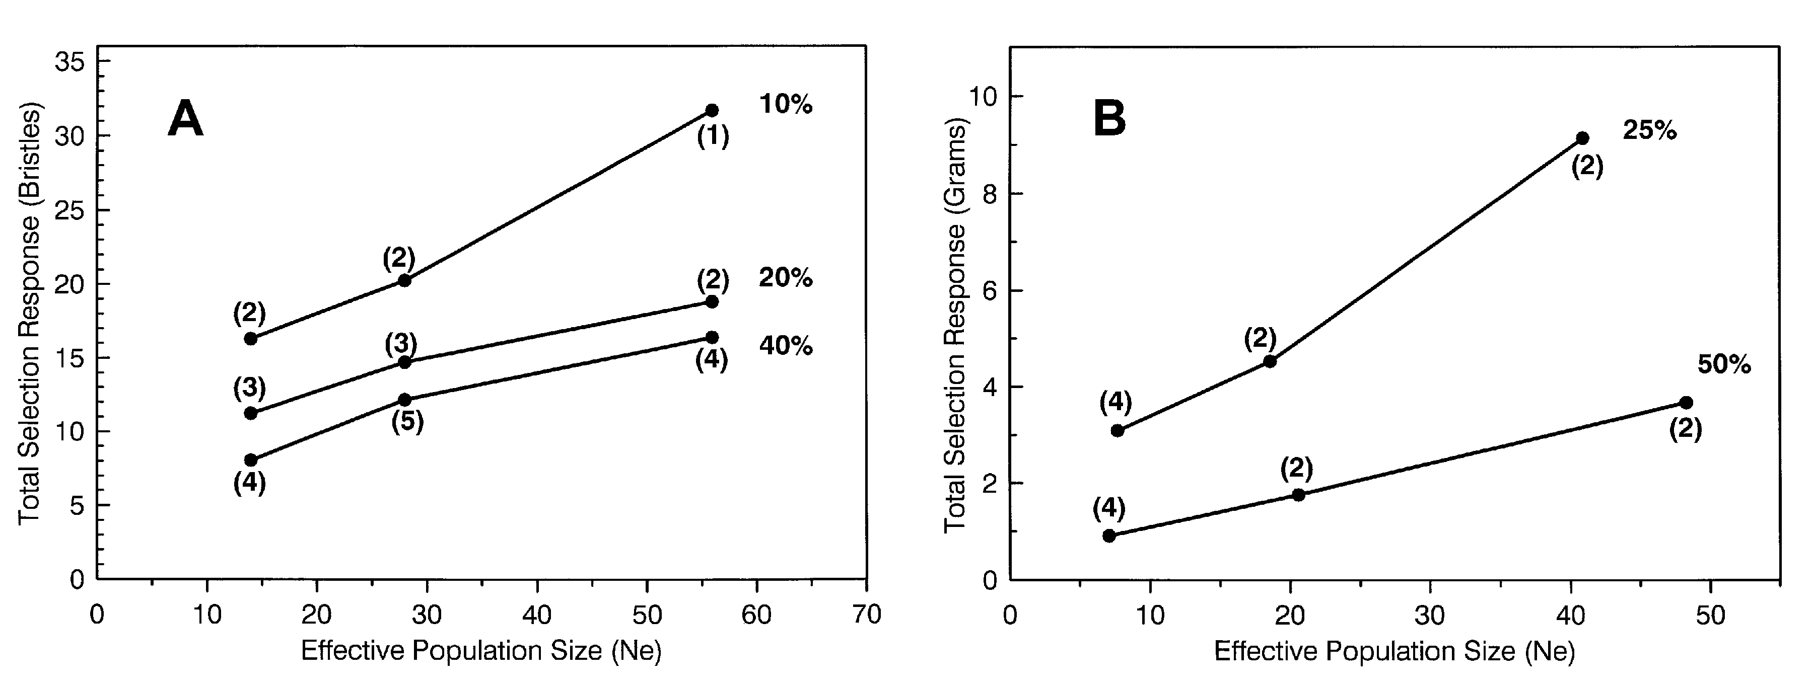

Figure 1: (A) Mean responses to selection for increased abdominal bristle number in D. melanogaster, after 50 generations. Data are for females. From Jones, et al., 1968. Estimated effective sizes following Frankham (1983). (B) Mean responses to selection for increased postweaning weight gain in mice, after 21-27 generations. Responses and calculated effective sizes from Eisen, 1975. In both graphs, each line connects three population sizes selected at the same intensity, given as a percent on right. Numbers of replicates per mean are in parentheses.

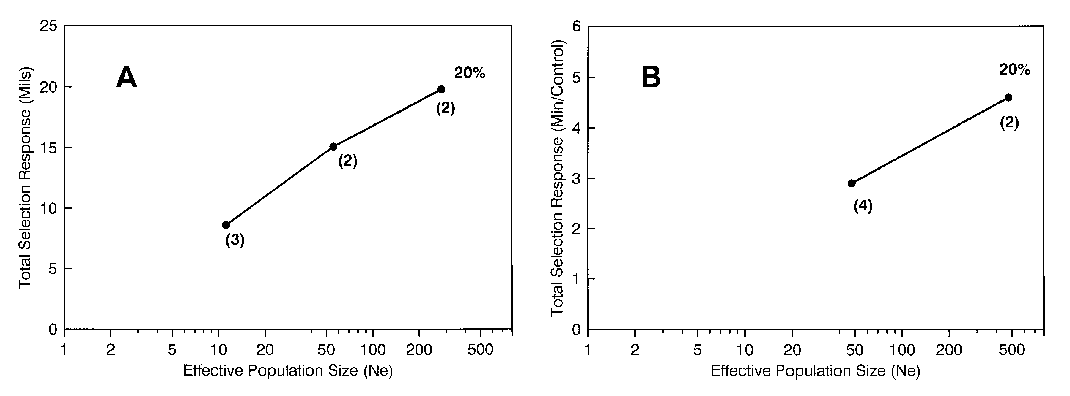

Figure 2: (A) Mean responses to selection for increased wing-tip height in D. melanogaster rsd homozygotes, after 55 generations. 1 mil = 0.001 in or 0.0254 mm. From Weber (1990) (B) Mean responses to selection for ethanol resistance in D. melanogaster, in minutes/control minute, after 65 generations. From Weber and Diggins (1990). Numbers of replicates are in parentheses and percent selected is to the right. Estimated effective sizes in both experiments following Weber and Diggins (1990). Response = final selected phenotype - control phenotype.
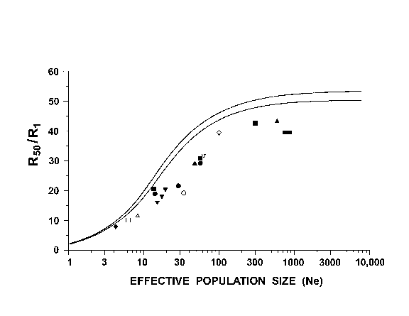Figure 3: A summary of 11 selection experiments showing total response in generation 50, normalized by response in generation one (R₅₀/R₁). The curves show predicted R₅₀/R₁, with and without new mutation at a rate of 0.001 x initial additive genetic variance per generation. Data are from Dudley (1977) on corn protein and oil content (), Enfield (1980) on Tribolium pupal weight (①), Jones, Frankham and Barker (1968) on fruitly abdominal bristles (), Mather and Harrison (1949) on fruitfly abdominal bristles (), Rasmuson (1955) on fruitfly sternopleural bristles (②), Reeve and Robertson (1953) on fruitfly wing length (), Roberts (1966a,b) on mouse body weight (), Weber (1990) on fruitfly wing-tip height (⓪), Weber and Diggins (1990) on fruitfly ethanol resistance (), Weber (1996) on fruitfly wind tunnel flight (), and Yoo (1980) on fruitfly abdominal bristles (). See Weber and Diggins (1990) for methods and for tabulation of all values of response and effective sizes, except for the datapoint from Weber (1996), which was derived later by the same methods.

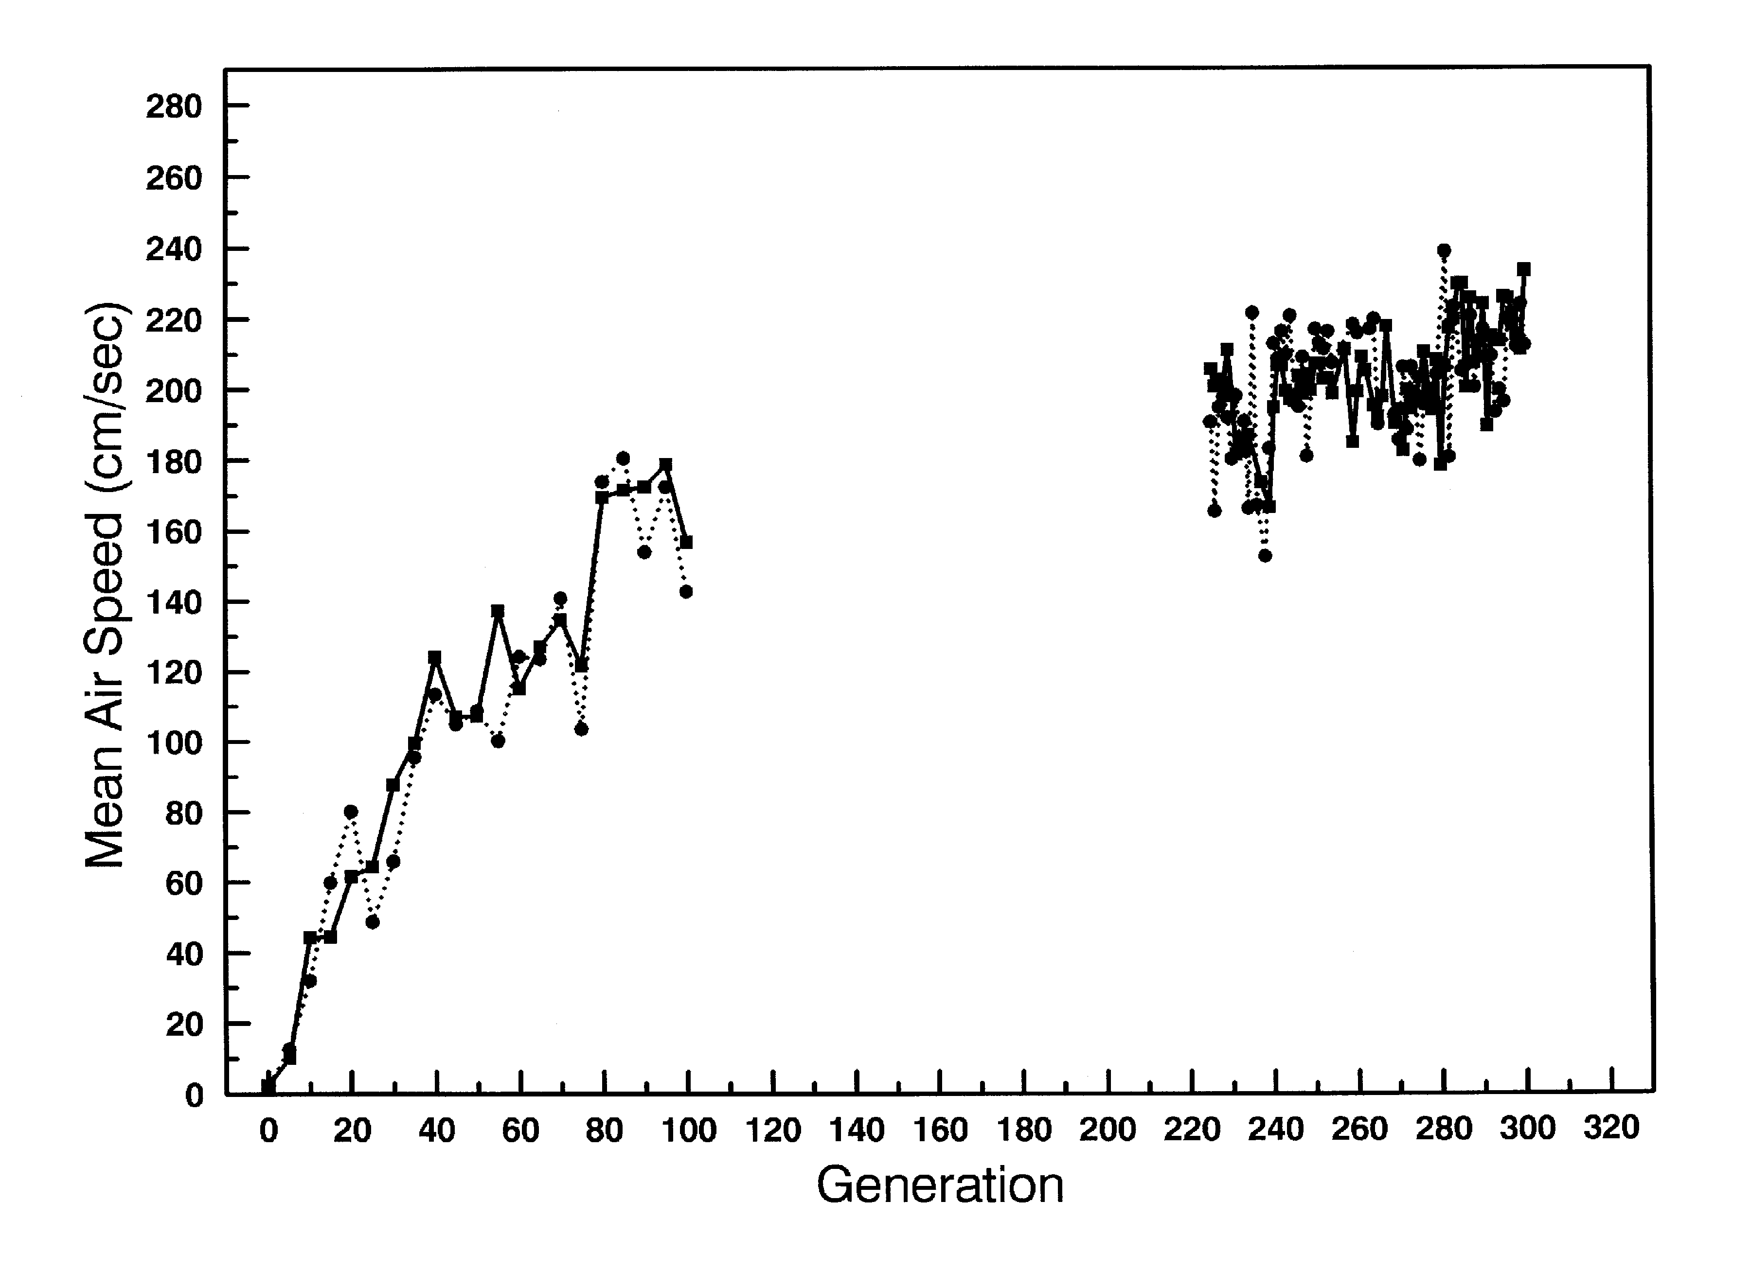
Figure 4: Response to selection for wind tunnel performance in both selected lines. Solid line, population AA1; dotted line, population AA2. First 100 generations as published in Weber (1996). Recent generations show that response is leveling off.
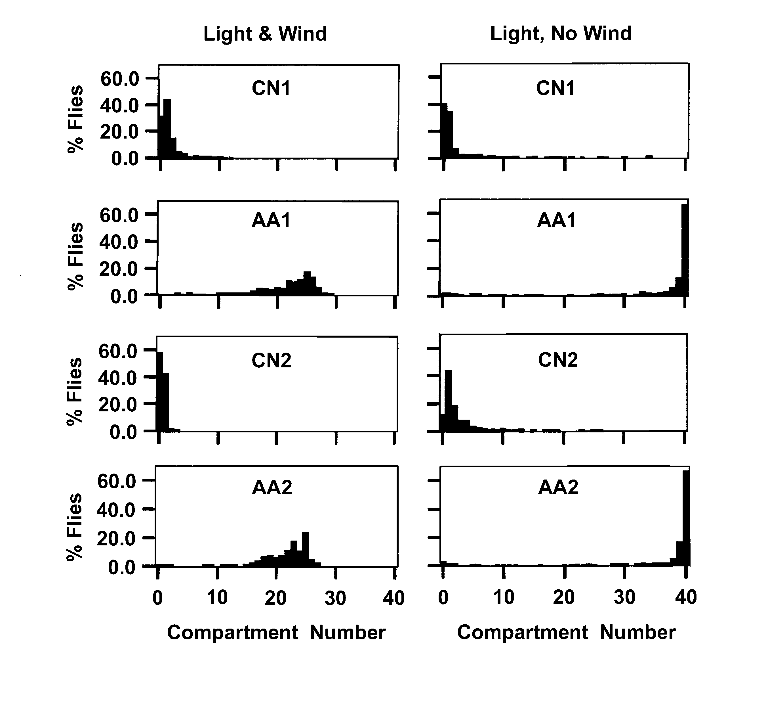
Figure 5: A test of phototaxis in the wind tunnel. The combination of light plus wind is the normal condition for a run. Selected populations are AA1 and AA2. Control populations are CN1 and CN2. Tests are from generation 198.

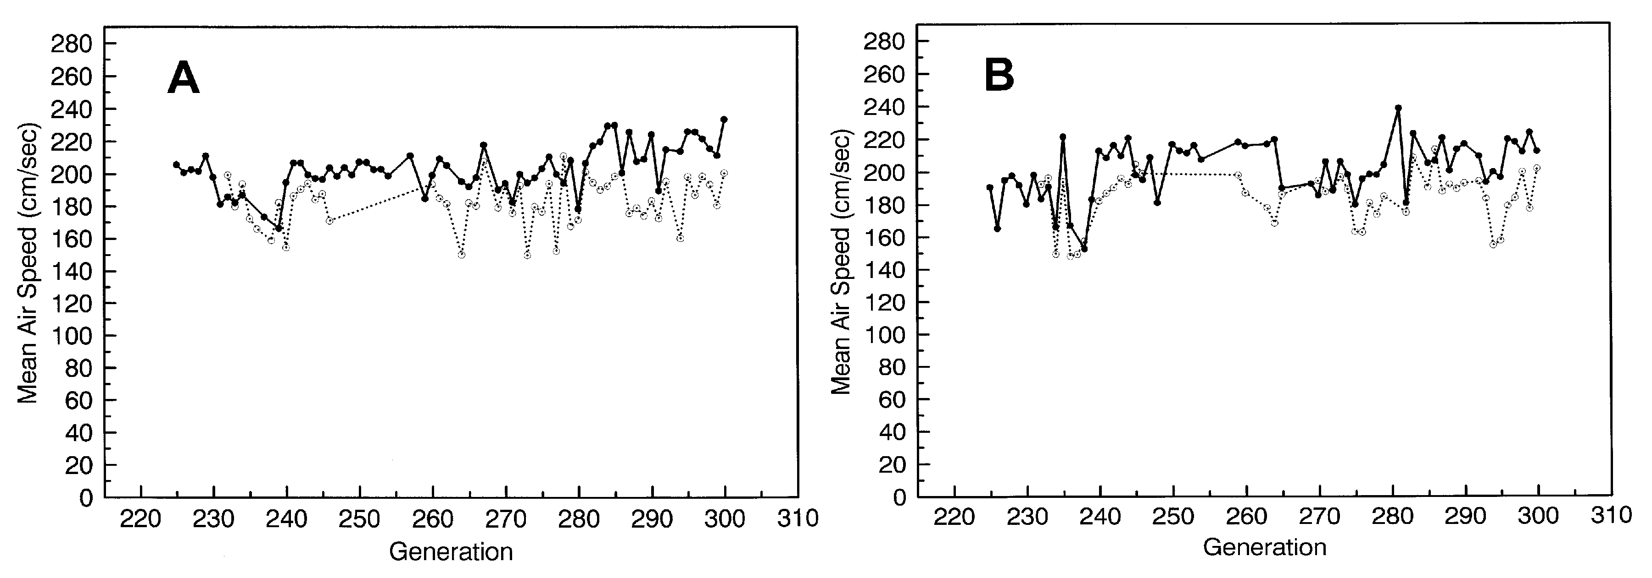

Figure 6: A comparison of selected populations (solid lines) and relaxed populations (dotted lines) from generation 232 to 300. A. AA1 and its relaxed population. B. AA2 and its relaxed population.

